Concurrent Enrollment Admission Instructions
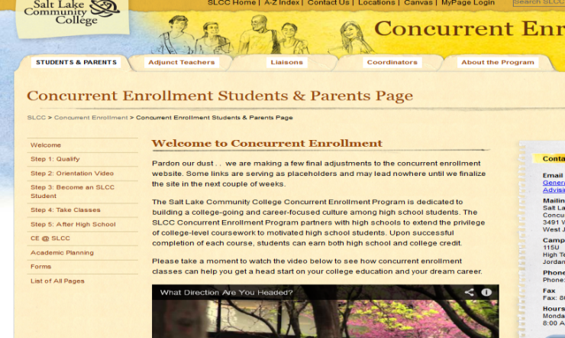
Step 1: Go to http://www.slcc.edu/concurrentenrollment/students/index.aspx

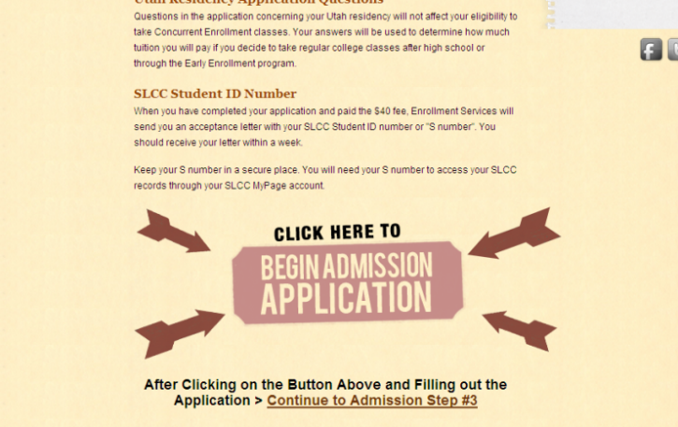
Step 2: Follow the steps on the left to apply. You may start with “Step 1: Qualifying”. “Step 2: Become a SLCC Student” will tell you what you need to apply before you begin the admission application. Once you have watched the video at the top, the “Begin Admission Application” button will appear at the bottom of the screen.

Step 3: Continue through to “Step 5: Transition to College”.
Step 4: Bring your “Confirmation of Acceptance” letter with your SLCC student number to the Career Center along with your signed “Memorandum of Understanding”.

**The Utah State Office of Education allows high school students to take a maximum of 30 credit hours of concurrent enrollment classes per year, including classes from different colleges and universities and various delivery methods such as online, traditional, hybrid, etc. The year begins in June with the summer term and ends with spring term.

